Hanggang ditto pa lang…

1. Table render on class click

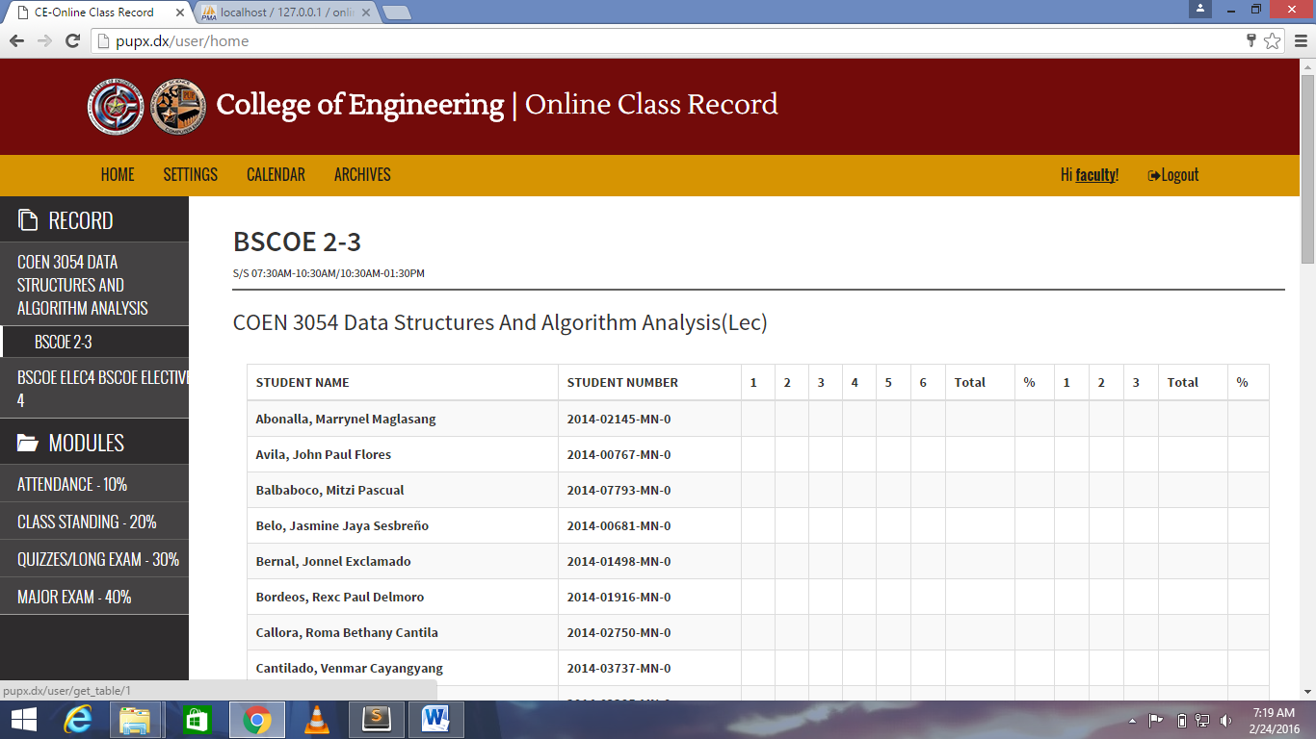

1. Upload pdf without success message

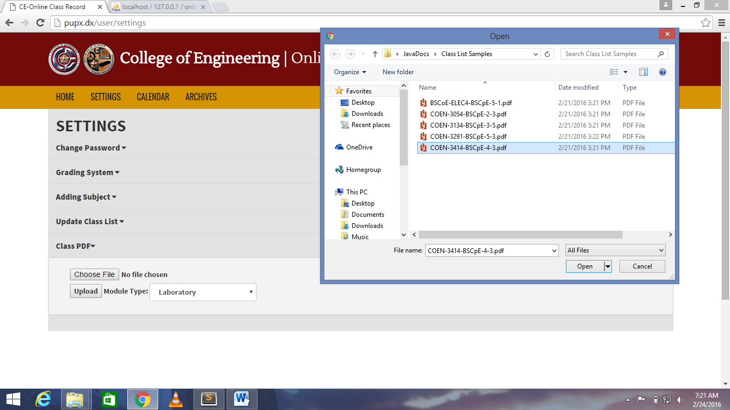

Pano ko matetest sa sarili kong xampp:

1. Pnta ako xampp ko localhost/phpmyadmin at create ako database name=’ online_class_record_system_for_ce’ then click ko and import online_class_record_system_for_ce.sql na kasama sa file.
2. Dahil mas secure kpag nasa loob p ng isang folder and index… kelangan gumawa ng virtual host para maaccess ng maayos.
   1. Open ko tong file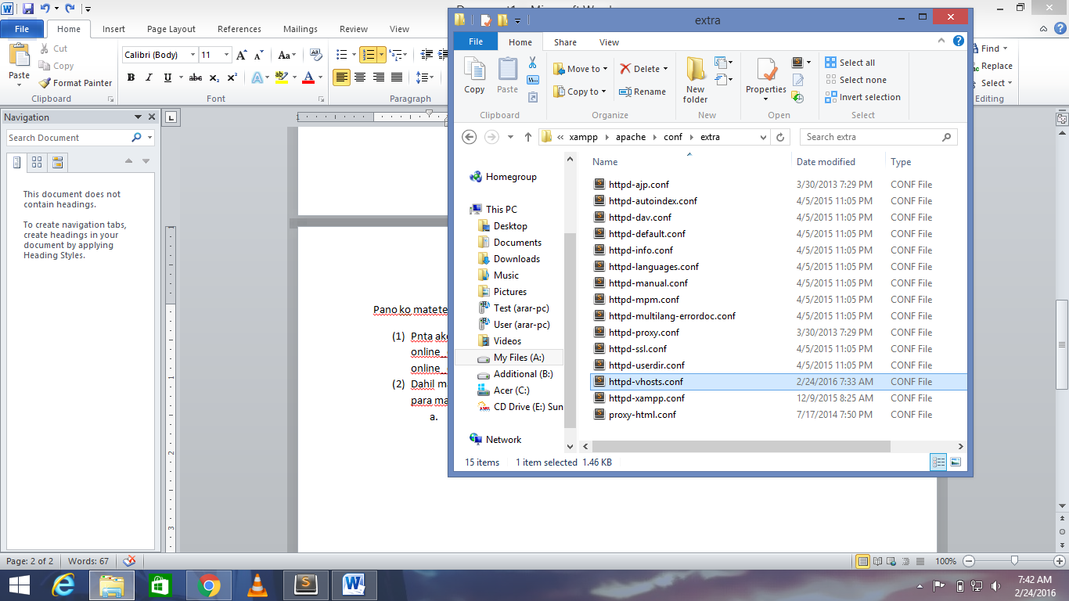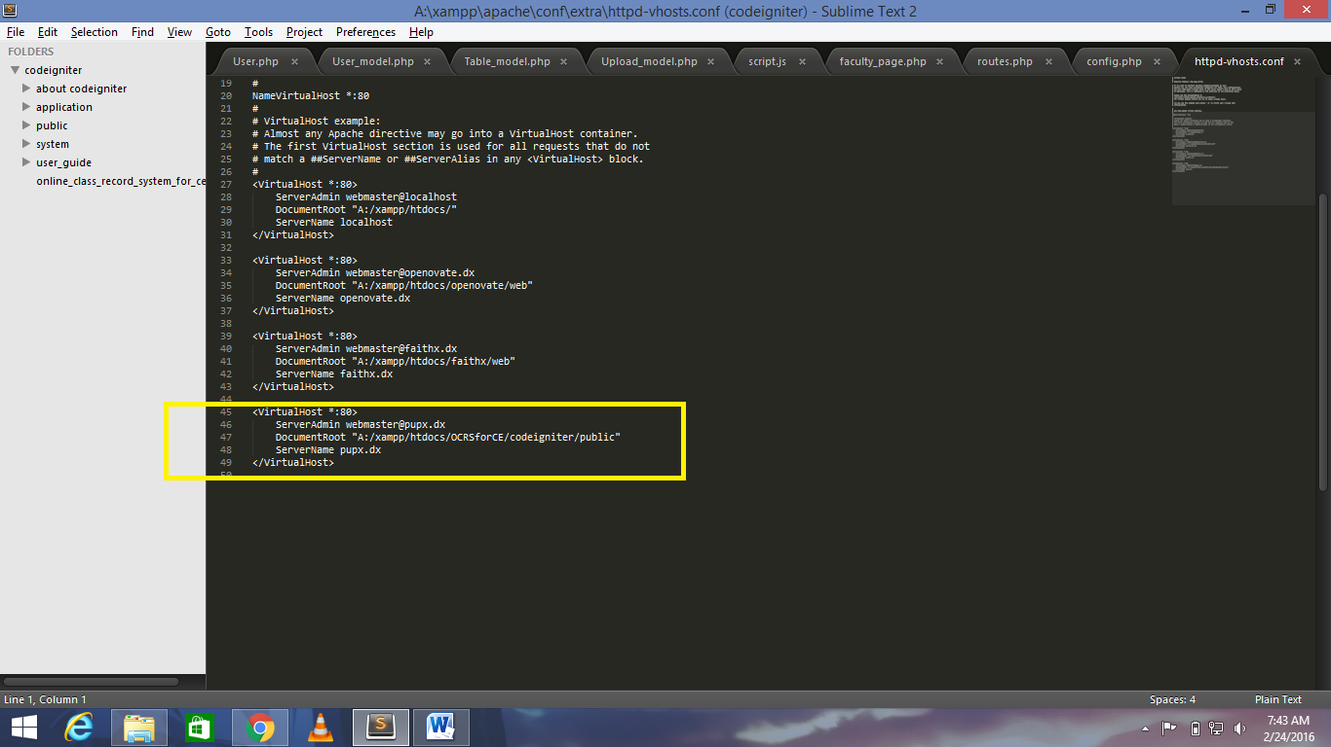 gayahin ko tong block na to then check ung document root kung nsan ung index.php save after edit.
   2. Pnta ko dito then cut ko ung file papunta sa desktop (hindi kasi maeedit sa directory na yan)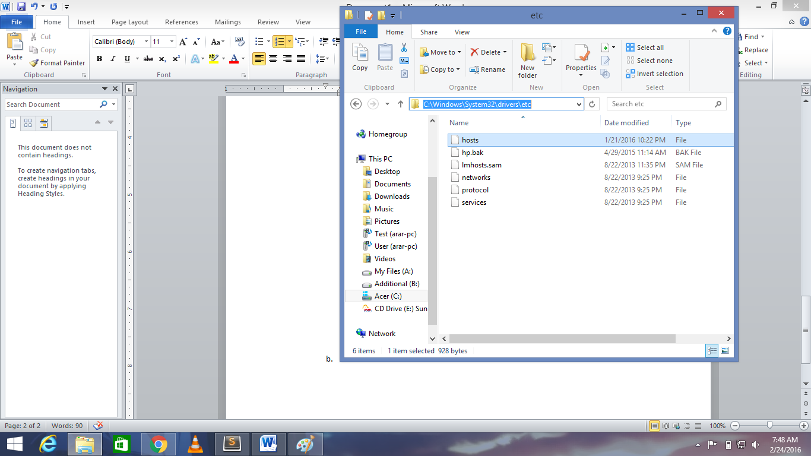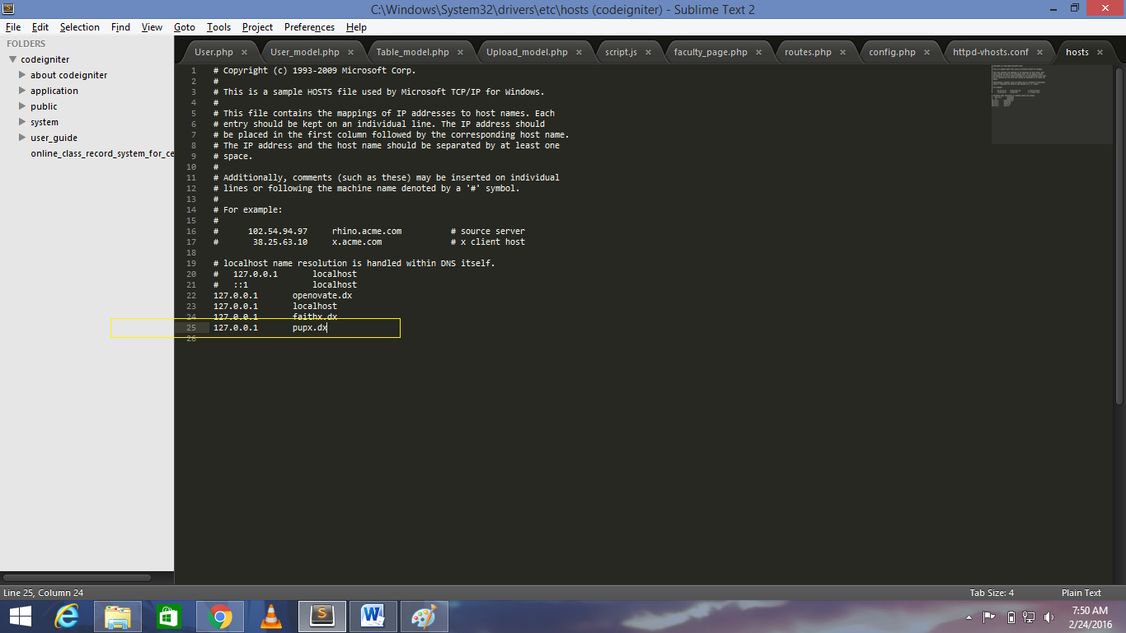ilalagay ko tong line na to then save ko tpos cut ko ulit pabalik sa folder.
   3. Open ko naman ito

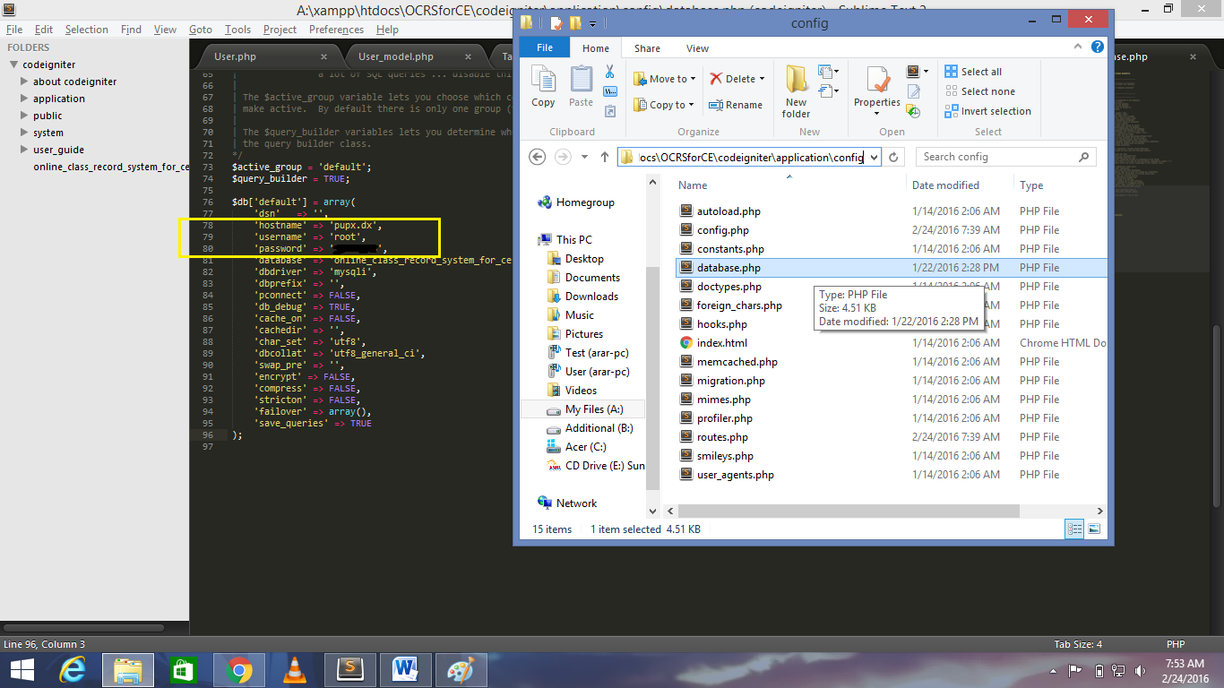

Edit ko ung user/pass ng xampp ko then save. (if naglagay ng ibang hostname dun sa vhost knina edit din ung hostname).

d.Open ko chrome then type sa url ‘http://pupx.dx’

(3) users currently created:

Username:admin, Password:admin

Username:faculty Password:faculty

If magccreate ako ng panibagong user pnta lng ako ditto ‘pupx.dx/user/regView’

(4) Merong mga sample ng classlist kasama dun sa zip folder if magtetest ako magupload.

Kung may tanong ako or hindi ko napagana ask ko lang sa bestfrend kong si Arian. Hindi siya alien kaya maiintindihan ko sya.

FOR BACKEND

--Database Java/VB— STRUCTURE

🡺 this symbol means that value in that column is being used to label another column from different database table (will be used for JOINING)

**Users**

-Id🡺*UserId*

-Username (Fname Initial+Surname)

-Password

-UserType (Admin/Chairperson/Faculty)

-UserDept (CE/ME/EE/IE/CpE)

-LoginHist //for admin

**Faculty**

-UserId

-Personal Infos(e.g. bday,#,etc)

-Fname

-Mname

-Sname

**Subjects**

-Id🡺*SubjectId*

-UserId

-SubjectTitle

**Class**

-Id🡺*ClassId*

-SubjectId

-ClassBlock(e.g. ‘BS CpE V – 1’)

-IsUploadYrSem (for validation only)

-ModuleType (lab or lect…to identify what module percentage to be used)

-NumStudents //for Assessment (maximum no. of students enrolled)

-YrSem (for archives)

-Passers //for Assessment

**ModuleItems**

-Id

-ClassId

-AttDate

-AssignNum

-AssignTItems

-SeatworkNum

-SeatworkTItems

-ExNum

-ExTItems

-LabNum

-LabItems

-QuizNum

-QuizItems

-LExamNum

-LExamItems

-PracExamNum

-PracExamItems

-MExamItems

-FExamItems

**LectModPerc(e.g. Attendance,Act)**

-Id

-Attendance - 10%

-Class Standing (Swork,Assign,Act..etc) - 20%

-Quizzes/Long Exam - 30%

-Major Exam(Midterm Exam/Final Exam) - 40%

**LabModPerc(e.g. Attendance,Act)**

-Id

-Lab / Machine Exercises - 45%

-Practical Exam - 25%

-Project (Midterm Proj/Final Proj) - 30%

**GradingSystem**

-Id

-1-1.25

-1.25-1.5

… etc

**Students**

-Id🡺*StudId*

-ClassId (get the Id of his class block)

-Firstname

-Middlename

-Surname

-StudentNumber

**Grades**

-Id🡺*StudGradeId*

-StudId

-MidTermGrade(get the average of each ratings e.g. ‘long exam’ multiply to module % then add with other modules like ’practical exam’)

-FinalGrade

-TotalGrade (add all ratings per module then calculate with the given module percentage)

-GradeRemarks(P/INC/W)

**Attendance**

-Id

*-*StudGradeId

-Status

-Rating (e.g. Rating = total(will be calculated on front end) * .10)

-Sem (to know if its midterm or final sem)

**Assignment**

-Id

*-*StudGradeId

-Score

-Rating (total items/score = %)

-Sem

**Seatwork**

-Id

*-*StudGradeId

-Score

-Rating

-Sem

**Exercises**

-Id

*-*StudGradeId

-Score

-Rating

-Sem

**LabActivity**

-Id

*-*StudGradeId

-Score

-Rating

-Sem

**Quizzes**

-Id

*-*StudGradeId

-Score

-Rating

-Sem

**LongExam**

-Id

*-*StudGradeId

-Score

-Rating

-Sem

**PracExam**

-Id

*-*StudGradeId

*-*Score

-Rating

-Sem

**MidTermExam**

-Id

*-*StudGradeId

-Score

-Rating

**FinalExam**

-Id

*-*StudGradeId

-Score

-Rating

Database Flow (sample for saving 1 seatwork score of a student in database)

*assuming pdf has been uploaded and professor is inputting grade for seatwork number 1

-after writing the score of a single student he clicked save button

-form will now be submitted to a controller and student number will be passed also (for querying)

-and some model will be used to know where to save that data

- UPDATE `Seatwork` SET Score =’ value’ WHERE Id = [query];

- Select ‘Id’ FROM `Seatwork` INNER JOIN `Grades` ON ‘Grades.Id = ‘Seatwork.StudGradeId’

INNER JOIN `Student` ON ‘Student.Id’ = ‘Grades.StudId’

WHERE ‘Student.StudentNumber’ = ‘(POSTED Student Number)’

-Student number is easier to query

-Done Saving

3 users can login:

-administrator

-chairperson

-faculty